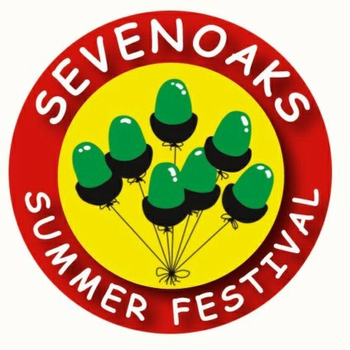
Festival 2025
21 June to 6 July
Flag Sponsorship Programme

RESPONSE FORM
Please return asap but no later than 9 May 2025
To Ray Russell, Sevenoaks Summer Festival. From:
Name: …………………………………………….………………………………….……………..…
Position: …………………………………………………….………….…………………………....
Company/firm: ……………………….……….…….……………….…………..…………..
Address: ..……..….….…..…………………………………………………………………...…..
…................................................. _{Post Code:} ………………..….
Contact details:
Tel no. ……………………………………………..
Mobile ………………………………………………
E-mail: ……………………………….…………… I/we wish to sponsor:
……….. flag(s) for 2025 and agree to pay £ ………… by *cash/cheque/BACS to 20-76-55 a/c no. 10012440
I/we do/do not * require an invoice (* delete whichever does not apply)

Signed: …………………………….………… Date: ………...……2025

Please email a hi-res image of your logo to rayrussell@sevenoaksfestival.org.uk
by 9 May 2025

